535/2
PHYSICS
July 2016
Paper 2
2¼ Hours

GREENHILL ACADEMY
MOCK EXAMINATIONS 2016
PHYSICS
Paper 2
2 Hours 15 minutes

INSTRUCTIONS TO CANDIDATES:
Answer any five questions.
Mathematical tables and silent non - programmable calculators may be used.
These values of physical quantities may be useful to you.
Acceleration due to gravity = 10 ms⁻²
Specific heat capacity of water = 4200 Jkg⁻¹K⁻¹
Specific heat capacity of copper = 400 Jkg⁻¹K⁻¹
Specific latent heat capacity of water = 340000 Jkg⁻¹K⁻¹
Speed of sound = 320 ms⁻¹

Density of water = 1000 kgm⁻³

- (a) Define the following terms:
- Uniform velocity. (1 mark)
- Displacement. (1 mark)
(b) The graph in the figure below shows the variation of velocity with time of a car.
0
8
16
20
24
t (s)
100
V(ms⁻¹)
80
60

(i) Describe the motion of the car. (4 marks)
(ii) Calculate the distance covered between the 8th and the 24th second. (3 marks)
(c) State the principle of conservation of linear momentum. (1 mark)
(d) A trolley P of mass 150 g moving with velocity of 20 ms⁻¹ collides with another stationary trolley Q of mass 100 g. If P and Q move together after collision,
Calculate the
(i) velocity with which P and Q will move after collision. (3 marks)
(ii) loss of kinetic energy of trolley P . (3 marks)

- a) i) What is a Kilo-watt-hour? (01 mark)
ii) Given that one unit of electricity costs shs. 450. Calculate the cost of using the following appliances. 3kW kettle, 60W light bulb and a 3000W immersion heater for 6hours. (03 marks)
- Explain the observations made when;
- An ebonite rod is rubbed with fur. (02 marks)
- A positively charged rod is brought near a positively charged gold leaf electroscope. (03 marks)
- i) With the aid of a diagram, describe the action of a simple cell. (04 marks)
ii) State any two advantages of a Knife cell. (01 mark)
- Explain the term local action in cells. (02 marks)
3. (a) (i) What is sound? (01 mark)
(ii) Describe with the aid of a diagram an experiment to determine the speed of sound in air using resonance method. (5 marks)
(b) (i) Distinguish between a node and an antinode. (02 mark)
(ii) Sketch a diagram of stationary waves corresponding to fundamental note and first overtone in closed pipe . (02mark)
(iii) What is an open pipe? (01 mark)
(c) A progressive wave travels a distance of 31.5m in 20 seconds. If the distance travelled is equivalent to the distance between 10 consecutive crests ,Calculate;
(i) the wave length of the wave. (02 mark)
(ii) the period of the wave. (02 mark)
(d) What is reverberation? (01 mark)
4. a) Define the following terms and state their S.I units.
- Latent heat of fusion
- Specific latent heat of vaporization (03 marks)
b) Explain why temperature remains constant during change of phase. (03 marks)
c) Describe an experiment to determine the specific latent heat of fusion of ice (06 marks)
d) An aluminium can of mass 102g contains 201g of water both initially at 17⁰c, are placed in a freezer at -60⁰. Calculate the quality of heat that has to be removed from the water and the can for their temperature to fall to -60⁰c. (Specific heat capacity of aluminium is 9000JK⁻¹, Specific latent heat of fusion of ice is 340,000kg-1, Specific heat capacity of ice 2100JKg⁻¹). (04 marks)

5. a) Sketch the magnetic field pattern around
- a straight wire carrying current
- a solenoid carrying current (04 marks)
b) (i) What is an electromagnet?
(ii) List down four uses of electromagnet. (03 marks)

c) (i) Define the term electromagnetism (01 mark)
(ii) Distinguish between mutual and self induction (02 marks)
(iii) State the factors that affect the magnitude of e.m.f induce in a conductor (02 marks)
(d) A transformer is designed to produce an output of 220V when connected to a 25V supply. If the transformer is 80% efficient, calculate the input current when the output is connected to a 220V, 75W Lamp. (04 marks)

- a) Distinguish between Primary and Secondary colors. Give examples of each. (03 marks)
b) Explain the appearance of a student wearing a green sweater in hall with yellow light. (02 marks)
c) (i) Define the terms “linear magnification” and “power “as used in lenses. (02 marks)
(ii) Describe am experiment to determine the focal length of a convex lens using a plane mirror. (05 marks)
d) An object of height 6cm is placed perpendicularly on the principal axis and 18cm from the convex lens of focal length 12cm. By graphical method, find;
(i) The position of the image
(ii) The magnification
- Power of the lens (04 marks)

- (a) Define the terms
- Half –life (01mark)
- Mass number (01mark)
(b) The count rate recorded by a Gerger-Muller tube of a radioactive source was as follows:
Count rate(min⁻¹) | 800 | 500 | 350 | 200 | 80 | 25
Time (min) | 0 | 1.0 | 1.8 | 3.0 | 5.0 | 7.5
- Plot a graph of count rate against time. (04 marks)
- Determine the half-life of the radioactive element. (02 marks)
(c) (i) What are x-rays? (01 mark)
(ii) With the aid of a diagram describe the production of x-rays in an x-ray tube. (05 marks)
- Give two uses of x-rays. (02 marks)

8. a) What is meant by the following terms?
i) Temperature, (1 mark)
ii) Fixed temperature points. (1 mark)

b) Briefly describe an experiment to determine the lower fixed point of a thermometer. (4 marks)
c) Mention two advantages and one disadvantage of using mercury as a thermometric liquid (3 marks)

d) The diagram in figure 2 below shows a flask fitted with a rubber bung and a length of glass tubing. The flask is filled with water such that the level of water comes up a short distance above the tube.
tube
Rubber bung
Fig. 2
Water

- State what is observed when the flask is plunged into a can of hot water. (1 marks)
- Explain your observation. (3 marks)

e) The pressure inside a motor tyre is found to be 190kPa at a temperature of 12⁰C. Calculate the pressure in the tyre if the motor car stands in the sun so that the temperature rises to 32⁰C? (3 marks)
(Assume the volume of air inside remains constant)

THE END

Uniform velocity is where the rate of change of displacement is constant/uniform
Displacement is the distance moved in a specific direction,
b) originally its moving at 100m/s decelerates uniformly to 60m/s in 8 s. it maintains this speed for 8 more seconds and then accelerates to a velocity of 80m/s in another 4 s and finally decelerates to rest in another 4 seconds
area under the graph
80
60
area of A +B+C
8 x 60 + (½ x 4 (60 +80) + ½ x 4 80
= …………………….m

c) total momentum before collision is equal to total momentum after collision for colliding bodies
d) m1u1 + m2u2 = (m1+m2)u3
150x 20 + 0 = 250 x u3
3000/250 = u3
U3 = 12 m/s
ii) loss in kinetic energy = KE after collision – KE before collision
(½ x250 x 12² – ½ x 150 x 20²)/1000
18 – 30
12 J

Kilo watt hour is the energy spent per second when a 1000 w device runs for a whole hour.
ii) (3 + 60/1000 + 3) kilo watts
(6.06 x 6 ) KWH
36.36 units x 450
16362 shs
Attraction : exchange of charges since fur has high work function gives negative charges to ebonite leaving it self positively charged and ebonite negatively charged. This causes attraction between the two.
Divergence : positive charges on the leaf induce negative ones on the cap and positive ones on the leaf and plate. This causes repulsion between the leaf and plate.
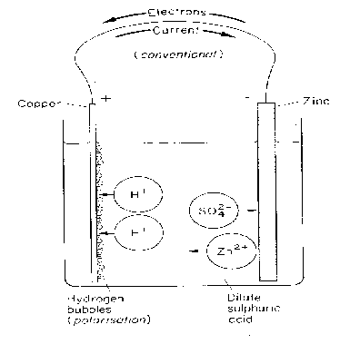

The zinc plate slowly dissolves and goes into the solution as zinc ions which displace hydrogen ions to form zinc sulphate.
Zn(s) → Zn²⁺(aq) + 2e⁻
Zn²⁺(aq) + SO₄²⁻ (aq) →ZnSO₄ (aq)
The displaced hydrogen ions move to the copper plate. They gain electrons and become neutralized. The two of these atoms combine to form gas that appears as bubbles on the copper plate.
2H⁺(aq) + 2e⁻ → H₂(g)
This flow of electrons from the cathode to anode causes the flow of electricity from the anode to the cathode hence the voltmeter deflects.
ii) An alkaline accumulator knife cell has the following adv
• Lasts longer./ Keeps the charge longer.
• Its E.M.F is relatively small
iii) local action is a defect in cells where hydrogen bubbles are formed as a result of impurities in the zinc plate. This erodes the plate.

is the form of energy that triggers the sensation of hearing
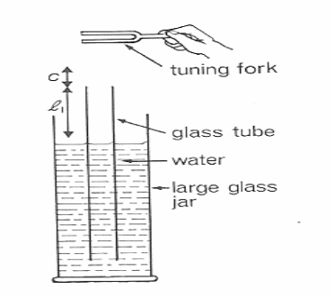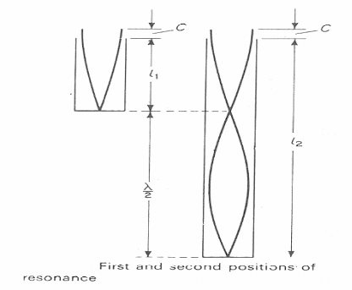

C – End correction
, - Length of air.
- Assemble the apparatus as in the diagram.
- Put a vibrating tuning fork just above the resonance tube.
- Gently lower the resonance tube until the 1st resonance (loud sound) occurs.
- Measure the length at which it occurs.
- + c = λ…… (i)
- Raise the resonance tube until the 2nd resonance (loud sound) occurs.
- Measure + c = λ…… (ii) as in diagram (b)
- Subtract equation (i) from (ii) to eliminate c
- ( - ) + (c-c) = λ -λ
- - = λ
- Wave length λ = 2 (- )…… (iii)
Hence the speed/velocity. V= fλ
V= 2f (
Antinodes- these are points that are permanently at rest. No disturbance occurs at these points.
Nodes : are points where there is maximum energy
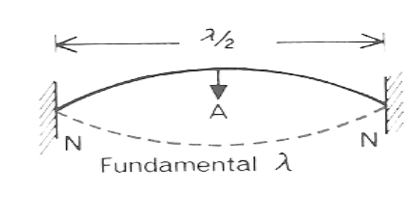

Wavelength = 31.5 / 10 = 3.15 m
V = x f
V = x . 1/T
T = x / v = 3.15/ 31.5 x 20
2 s

Reverberation is the prolonged sound

Heat required to change a mass of a substance from liquid to solid or vice versa with out change in temperature. J/kg
Specific latent heat of vapurisation is the qty of heat required to convert a unit mass of a substance from liquid to gas with out change in temperature.

Experiment to determine the specific latent heat of fusion of ice
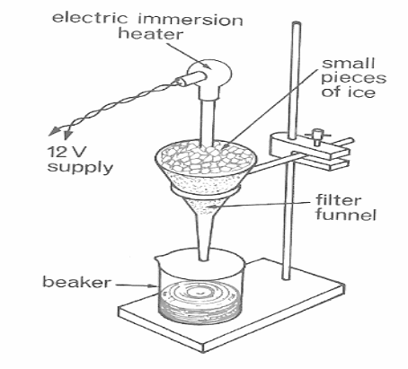Set up.

Procedure;
Support the plastic funnel using the retort stand.
Arrange the apparatus as in the diagram without the beaker.
When the water in the funnel starts dripping at a uniform rate, switch on the immersion heater and place the beaker under the funnel at the same time.
After sometime (t) of warming ice using the heater (of known power (p),
Remove the beaker and the mass (m) of the water collected in the beaker is weighed.
Calculate the specific latent heat of fusion of ice from:
Heat absorbed by ice = Heat supplied by heater
MLf = Pt

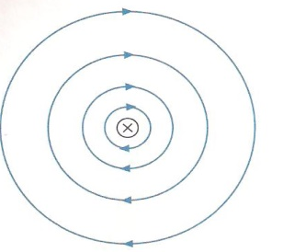
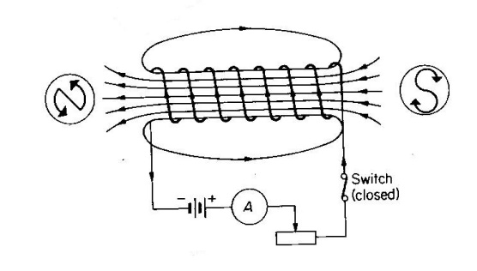
5) i)
ii)

it’s a device that can easily be magnetized and demagnetized when ever current passes through a solenoid.
It can work as a switch, magnet to separate /select metals, balances , starters for cars
Is the study of electric current in relations to magnets
Mutual induction is where flux linking in one coil causes a change in another coil. While self induction is where flux linking in one coil changes in the same coil.
- Speed of rotation of the coil
- Current in the coil
- Strength of the coil

Primary colours are those colours which can not be obtained by mixing any other colours eg red
Secondary colours are colours that obtained after mixing primary colours eg yellow

The green sweeter will appear yellow since the green sweater absorbs green and reflects yellow

Ratio of image distance to object distance

Is the reciprocal of the focal length in metres

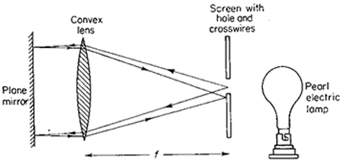
Procedure
- A lens is set up in a suitable holder with a plane mirror behind it so that light passing through the lens is reflected back as shown above
- Across wire is used as the object in a hole of a white screen. It is illuminated by the bulb
- The position of the lens is adjusted until a sharp image of the object is formed on the screen along side the object.
- The distance between the lens and the screen is measured, this gives the focal length of the lens .

7) half life is the time aken for ½ the radioactive atoms to disintergrate

Mass number is the total number of protons and neutrons in the nucleus

These are electromagnetic rays formed when fast moving electrons are stopped by matter

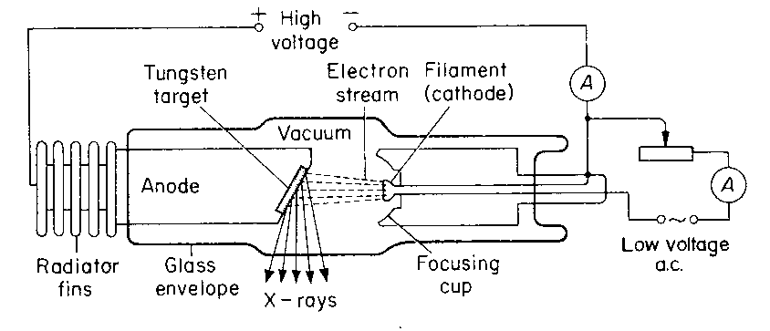
The cathode is heated to emit electrons by thermionic emission .using a low voltage supply. A large p.d is used on the anode to accelerate the electrons. On reaching the anode, the first moving electron is hit the metal target off a high melting point.
The kinetic energy of electrons is converted into heat and x- rays.
The x – ray tube is evacuated to prevent fast moving electrons from being hindered by friction due to air resistance. The heat generated is conducted away thru the copper anode to the cooling fins
The magnitude of x-rays produced is determined by the number of fast moving electrons heating the target.

Soft x rays are used for treatment of cancer and checking fractures in bones
Hard x rays are used for determining cracks in metals

Is the degree of hotness or coldness of a bpody
Are temperatures of pure melting ice and steam
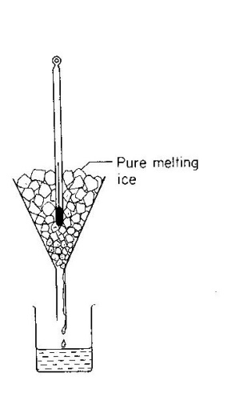

Procedure;
-support the funnel on a retort stand as shown above.
-put the thermometer in funnel packed with pure melting ice.
- Adjust the thermometer so that the mercury thread is clearly seen.
-mark the points where the level of mercury stops is the lower fixed point.

Mercury is opaque
Expands linearly with temperature

The water level will first rise and then fall
Iit rises

